**Exp No:2 Upload and Analyze the data set given in csv format and perform data**

**preprocessing and visualization.**

**Description**: Use sample data set sales-data.csv.

import pandas as pd

import numpy as np

import matplotlib.pyplot as plt

df=pd.read_csv('sales.csv')

print(df.head())

print(df.isnull().sum())

print(df.describe)

**OUTPUT:**

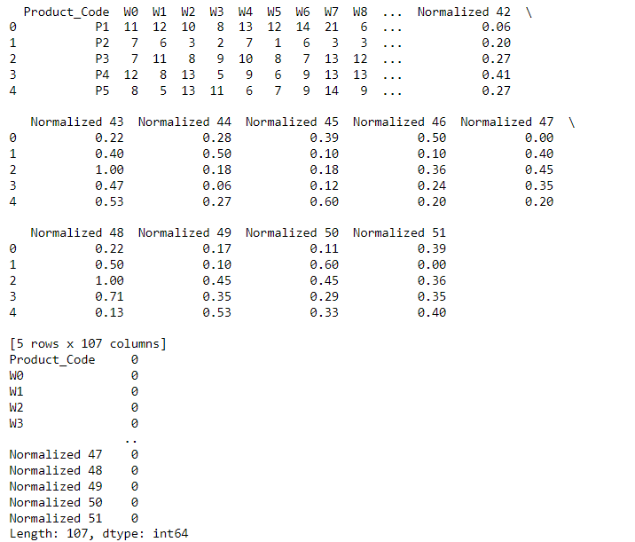

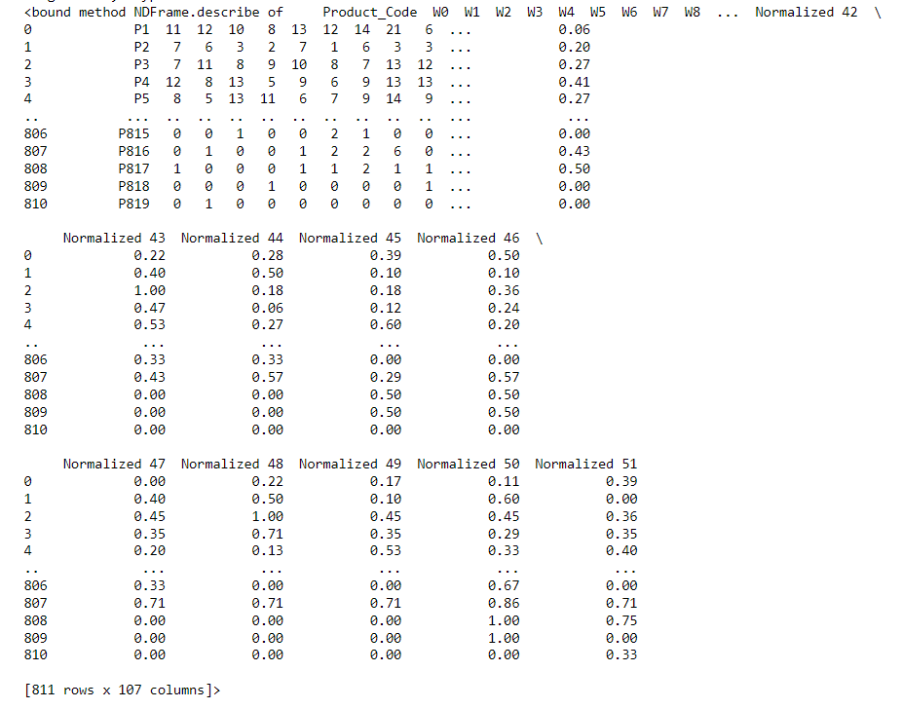

**Description:** Bar graphbofvthe product vs their weekly sales

**CODE:**

import pandas as pd

import matplotlib.pyplot as plt

df = pd.read_csv('sales.csv')

subset_df = df.head(10)

plt.figure(figsize=(10, 6))

plt.bar(subset_df['Product_Code'], subset_df['W1'],color='Purple')

plt.xlabel('Product_Code')

plt.ylabel('W1')

plt.title('Bar Graph of the Product vs their weekly sales')

plt.xticks(rotation=45)

plt.show()

**OUTPUT:**

